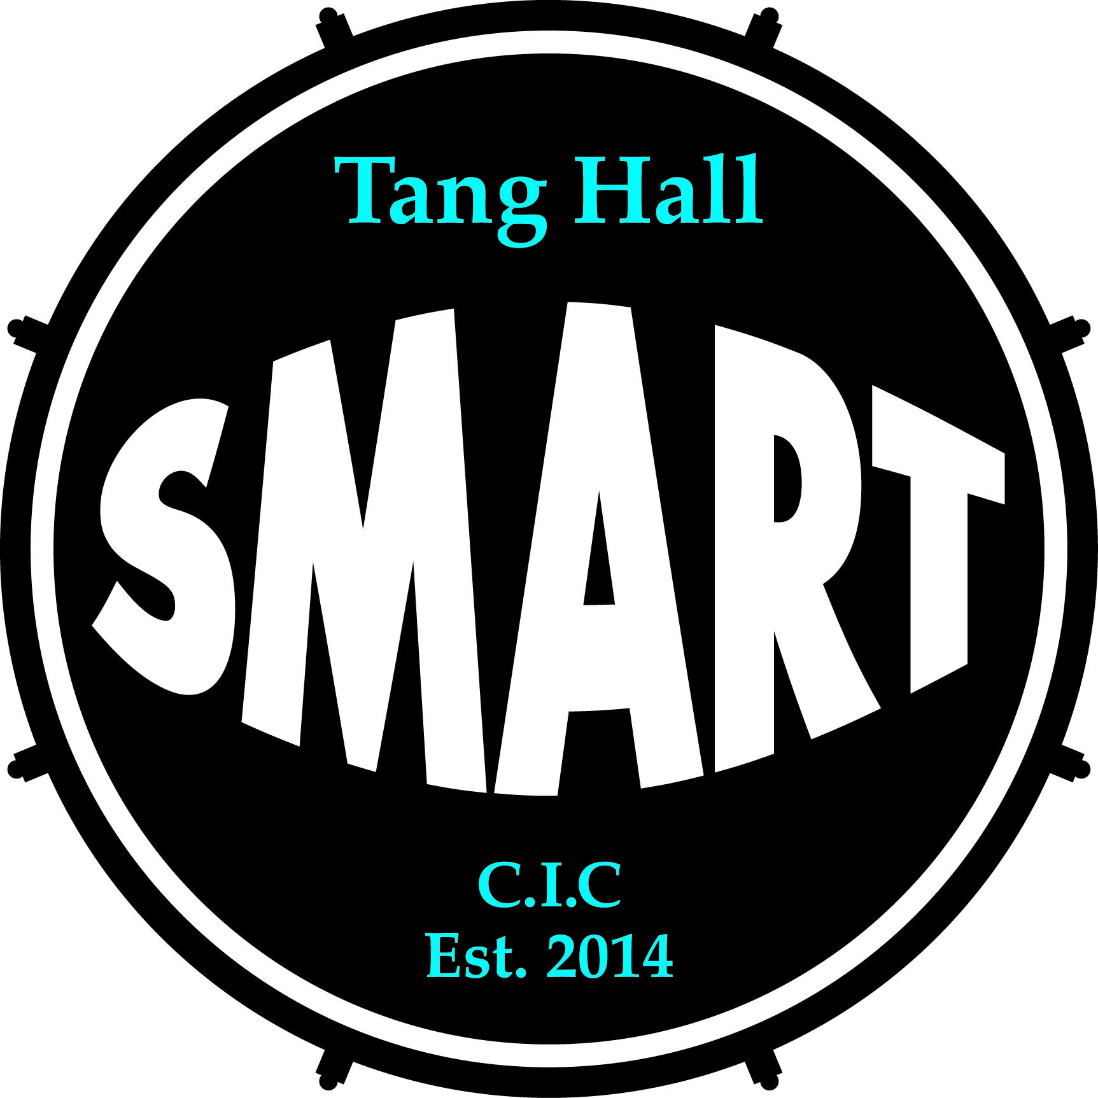

At Tang Hall Smart CIC our Complaints Policy is underpinned by our key principles:
- Everyone is equal and different, with their own gifts
- Everyone has the ability to develop
- Everyone has needs and the right to support in keeping with their human rights
- Everyone’s relationships are valuable

CHILD PROTECTION, SAFEGUARDING AND PREVENT POLICY

Section heading | Section content
- Introduction | Tang Hall SMART CIC makes a positive contribution to a strong and safe community and recognises the right of every individual to stay safe. Tang Hall SMART CIC recognises safeguarding is everyone’s responsibility.  Tang Hall SMART CIC comes into contact with children and vulnerable adults through a range of provisions that are delivered on a day to day basis.  This policy seeks to ensure that Tang Hall SMART CIC undertakes its responsibilities with regard to protection of children and vulnerable adults and will respond to concerns appropriately. The policy establishes a framework to support staff and volunteers in their practices and clarifies the organisation’s expectations.
Key Roles and Responsibilities:

Susan Williamson - Managing Director and Designated Safeguarding Lead (DSL) - sue@tanghallsmart.com 07725 997342

Hayley Evans - EHCP/Pastoral Lead and Deputy Safeguarding Lead - hayley@tanghallsmart.com

Carmel Appleton - Chair of the Board of Directors - tanghallsmartchair@gmail.com

All staff and volunteers have a responsibility to:
- follow the guidance laid out in this policy and related policies
- pass on any concerns using the required procedures.
- promote good practice by being an excellent role model
- contribute to discussions about safeguarding
- positively involve people in developing safe practices.
- Receive and understand child protection and safeguarding training annually
- Understanding the reporting structure within the safeguarding protocol
- Maintain an attitude of “it can happen here” where safeguarding is concerned.
- Provide a safe environment where students can learn
- Speak to the DSL if unsure of safeguarding matters
- Maintain confidentiality when dealing with disclosures.

Additional specific responsibilities

The Board of Directors have responsibility to ensure the policy is appropriate, is regularly reviewed and updated.

The DSL’s responsibilities are:
- To ensure the policy is accessible and implemented
- To promote the welfare of children and vulnerable adults
- To ensure staff have access to appropriate training and information
- Receive staff concerns about safeguarding and respond to them seriously, swiftly and appropriately
- Keep up to date with local arrangements for safeguarding and DBS
- Develop and maintain effective links with relevant agencies.

- Legislation | The principal pieces of legislation governing this policy are:  - Keeping Children Safe in Education 2022  - Counter-Terrorism and Security Act 2015 (Prevent Duty)  - Health And Safety At Work Act 1974  - Human Rights Act 1998  - United Nations Convention on the Rights of the Child  - Data Protection Toolkit in Schools 2023  - Guide to the UK General Data Protection Regulations 2018  - Care Act 2014  - Children and Families Act 2014  - Equality Act 2010  - Working together to safeguard Children 2018  - The Children Act 1989  - The Adoption and Children Act 2002:  - The Children Act 2004  - Safeguarding Vulnerable Groups Act 2006  - Care Standards Act 2000  - Public Interest Disclosure Act 1998  - The Police Act – CRB 1997  - Mental Health Act 1983  - NHS and Community Care Act 1990  - Rehabilitation of Offenders Act 1974
- Definitions | Safeguarding is about embedding practices throughout the organisation to ensure the protection of children and / or vulnerable adults wherever possible. In contrast, child and adult protection is about responding to circumstances that arise.  Abuse is a selfish act of oppression and injustice, exploitation and manipulation of power by those in a position of authority. This can be caused by those inflicting harm or those who fail to act to prevent harm. Abuse is not restricted to any socio-economic group, gender or culture.  It can take a number of forms, including the following:  - Physical abuse  - Sexual abuse  - Emotional abuse  - Bullying  - Neglect  - Financial (or material) abuse  - Modern Slavery  - Institutional abuse  - Discriminatory Abuse  - Online Abuse  - Radicalisation and Extremism  - Female Genital Mutilation  - County Lines  - Child sexual assault  - Peer on peer abuse  - Sexting and sharing of indecent images  - Upskirting  All forms of abuse can take place online and it is part of our practice to foster an open environment in which children, young people and vulnerable adults are encouraged to ask any questions and participate in an ongoing conversation about the benefits and dangers of the online world.  Definition of a child  A child is under the age of 18 (as defined in the United Nations convention on the Rights of a Child).  Definition of Vulnerable Adults  A vulnerable adult is a person aged 18 years or over who may be unable to take care of themselves or protect themselves from harm or from being exploited.  This may include a person who:  - Is elderly and frail  - Has a mental illness including dementia  - Has a physical or sensory disability  - Has a learning disability  - Has a severe physical illness  - Is a substance misuser  - Is homeless  With regard to the 2014 Care Act , “Well-being”, in relation to a vulnerable adults, means that individual’s well-being so far as relating to any of the following— (a) personal dignity (including treatment of the individual with respect); (b) physical and mental health and emotional well-being; (c) protection from abuse and neglect;  (d) control by the individual over day-to-day life (including over care and support, or support, provided to the individual and the way in which it is provided); B Care Act 2014 (c. 23) Part 1 — Care and support 2 (e) participation in work, education, training or recreation; (f) social and economic well-being; (g) domestic, family and personal relationships; (h) suitability of living accommodation; (i) the individual’s contribution to society  Definition of Prevent Duty  With regard to the Prevent Duty, (Counter-Terrorism and Security Act 2015) we have a duty to liaise with the local authority - 37. “Prevent work conducted through local authorities will often directly involve, as well as have an impact on local communities. Effective dialogue and coordination with community based organisations will continue to be essential.” This with particular regard to clients referred from Probation and Health Services who are specifically mentioned in the act as having a duty of care.  Radicalisation is the process by which people come to support terrorism and extremism and, in some cases, to then participate in terrorist groups.  Extremism is the vocal or active opposition to fundamental British values, including democracy, the rule of law, individual liberty and mutual respect and tolerance of different faiths and beliefs.
4. Working Together | Tang Hall SMART CIC contributes to multi-agency working as part of statutory requirements. We work with all appropriate agencies for the best outcomes for service users. This could include working with Health Teams, Children’s and Adult Social Care, Youth Justice and contributing to multi agency plans such as child in need and child protection.  We recognise the importance of proactive information sharing to ensure we report concerns and relevant information to the appropriate bodies promptly.  https://www.safeguardingadultsyork.org.uk/  https://www.york.gov.uk/ChildProtection
- Students At Greater Risk Of Harm | Tang Hall SMART CIC recognises that some students are at a greater risk of harm than others. Students at greater risk of harm include:  - Care Experienced, Care Leavers and Adopted Children  - Staff should be aware that these students may need additional services, assistance, protection and consideration.  - The EHCP Lead (currently Hayley Evans) - who is also the Deputy DSL is the main point of contact for coordinating with external agencies involved with these students.  - Tang Hall SMART CIC will liaise as necessary with the social worker, personal advisor and/or next of kin regarding any concerns.  - Students with Special Educational Needs and Disabilities  - Staff should be aware that these students may face additional safeguarding challenges.  - Additional barriers can exist when recognising abuse and neglect in this group of students including communication barriers.  - Staff must also be aware that these students may not outwardly show any signs of abuse:  - Further explore possible indicators of abuse such as behaviour, mood and injury without making assumptions that these factors relate to the student’s disability;  - Seek the voice of the student at all times and not become disproportionately over-reliant on the voice and views of the parent/carer;  - Monitor these groups of students to ensure that they are not being disproportionately impacted by behaviours such as bullying or peer group isolation.  - Children who are lesbian, gay, bisexual and/or trans (LGBT+)  - The fact that a child or young person may be LGBT is not in itself an inherent risk factor for harm. However, in line with ‘Keeping Children Safe in Education’, we recognise that young people who are LGBT+ or those perceived by others to be LGBT+ could potentially be more vulnerable and we work to reduce any additional barriers faced.  - Students with a Child Protection plan or Child in Need Plan  - Staff should be aware that these students may need additional support, services, assistance, protection and consideration.  - The EHCP Lead (currently Hayley Evans) is the main point of contact for coordinating with external agencies involved with these students.  - Staff are expected to work with the EHCP Lead and provide accurate updates on students progress and report concerns promptly. This will allow any issues and/or support needs to be identified early and allow for appropriate action to be taken in response.  - Tang Hall SMART CIC will liaise as necessary with the social worker, external agencies and next of kin, as appropriate regarding any issues of concern affecting the student.  - Students may benefit from Early Help support. Any student may benefit from Early Help, but staff should be alert to the potential need for early help for a student who:  - has health conditions, specific additional needs and/or special educational needs regardless of whether they have a statutory Education, Health and Care Plan;  - is a young carer;  - has a mental health need;  - is showing signs of being drawn into anti-social or criminal behaviour,  - is frequently going missing/goes missing from care or from home;  - is at risk of modern slavery, trafficking, sexual or criminal exploitation;  - is at risk of being radicalised or exploited;  - is in a family circumstance presenting challenges for the student, such as  - substance misuse, adult mental health and domestic abuse;  - has a family member in prison, or is affected by parental/carer offending;  - is misusing substances themselves;  - has returned home to their family from care;  - is a privately fostered child;  - is at risk of honour-based abuse  - Is persistently absent from education, including persistent absences for part of  the College day.
- Implementation Stages | The scope of this Safeguarding Policy is broad ranging and in practice, it will be implemented via a range of policies and procedures within the organisation. These include: Peer on Peer/Child or Child Abuse Policy, Safer Recruitment Policy Behaviour Policy, Staff behaviour policy, Acceptable use of ICTY Agreement, Grievance and disciplinary procedures, health and safety policy, equality and diversity policy, data protection policy.
- Communications training and support for staff | Tang Hall SMART CIC commits resources for induction, training of staff, effective communications and support mechanisms in relation to Safeguarding  Training  All staff who, through their role, are in contact with children and /or vulnerable adults will have access to safeguarding training at an appropriate level. Sources and types of training will include: regular staff training sessions, online training, 1-1 training with line managers and safeguarding updates to be circulated between staff  Communications  We ensure effective discussion of safeguarding issues between staff through team meetings and one-to-one meetings between employees and their line manager.  Support  - Debriefing support for staff or volunteers so that they can reflect on the issues they have dealt with is provided by the DSL, Deputy DSL or Key Support Worker (Graham Rogers) or a staff member’s line manager.  - Staff will seek further support as appropriate e.g. access to counselling/supervision for themselves/others. Support from Westfield Health EAP scheme available for all staff.
Professional boundaries | Professional boundaries are what define the limits of a relationship between staff member and a student/service user. They are a set of standards we agree to uphold that allows this necessary and often close relationship to exist while ensuring the correct detachment is kept in place.  Tang Hall SMART CIC expects staff to protect the professional integrity of themselves and the organisation.  The following professional boundaries must be adhered to:  - Staff contact with user groups. Personal relationships between a member of staff or volunteer and a client who is a child or vulnerable adult is prohibited. This includes relationships carried out through social networking sites such as Facebook/Instagram/Twitter/Snapchat etc.. Tang Hall SMART CIC has its own social media pages, and clients can be directed to this. It is also prohibited to enter into a personal relationship with a child or vulnerable adult who has been a service user over the past 12 months.  - Staff should not have physical contact with students and service users as standard. There may be occasions where it is appropriate for a staff member to physically touch a student, for example, for comfort at the request of the service user or first aid. This must be with permission, and only done for an appropriate purpose.  If the professional boundaries and/or policies are breached this could result in disciplinary procedures.
Reporting | The process outlined below details the stages involved in raising and reporting safeguarding concerns at Tang Hall SMART CIC:  Communicate your concerns with The Designated Safeguarding Lead (currently Sue Williamson) in the first instance or with the Deputy Safeguarding Lead, Hayley Evans.  Seek medical attention for the vulnerable person if needed  The DSL or Deputy DSL could either a) discuss with parents of child/vulnerable adult - or with vulnerable person if appropriate and obtain permission to make referral if safe and appropriate – or b) inform/liaise with any contractors involved in the event that the vulnerable person is on a paid placement involving another organisation.  If needed seek advice from MASH (Multi agency safeguarding hub) or Safeguarding Adults Board:  Multi Agency Safeguarding Hub:  Mon-Fri 8.30 – 4.30: Tel 01904 551900  Email: mash@york.gov.uk  Emergency duty team (evenings and weekends): 01609 780780  Vulnerable adults  City of York Safeguarding Adults Board (SAB):  Telephone: 01904 555111  Email: socialsupport@york.gov.uk  Complete the Local Authority Safeguarding Vulnerable Groups Incident Report Form if required and submit to the local authority within 24 hours of making a contact  Ensure that feedback from the Local Authority is received and their response recorded  In the instance of emotional distress/challenging behaviours, please refer to the Behaviour Policy.
9. Whistleblowing | Tang Hall SMART CIC recognises its duty to report concerns or allegations against its staff or volunteers within the organisation or by a professional from another organisation.  The process for raising and dealing with allegations is as follows:  First step: Any member of staff or volunteers from Tang Hall SMART CIC is required to report any concerns in the first instance to the DSL or Deputy DSL. In the event that the allegation is against one of these then, the person to contact would be the Chair of the Board of Directors (currently Carmel Appleton).  Second step: contact the local authority for advice.  Third step: follow the advice provided  Tang Hall SMART CIC recognises its legal duty to report any concerns about unsafe practice.  Where we have a safeguarding concern about a professional or volunteer who works with children, this matter would be notified to the LADO Service. Where appropriate, a referral should be sent to the LADO using the LADO Referral Form which is also available on the CYSCP website. giving as much detail as possible. Completed forms should be emailed to: lado@york.gov.uk. The LADO can be contacted on 01904 551783.  https://www.saferchildrenyork.org.uk/safeguarding-information/allegations-childcare-workers-professionals#concern
- Monitoring | The organisation will monitor the following Safeguarding aspects:  - Safe recruitment practices  - DBS checks undertaken  - References applied for new staff  - Records made and kept of supervision sessions  - Training – register/ record of staff training on child/ vulnerable adult protection  - Monitoring whether concerns are being reported and actioned  - Checking that policies are up to date and relevant  - Reviewing the current reporting procedure in place  - Our use of the Internet
11. Online Safeguarding | At Tang Hall SMART most students will use ICT as part of their studies. Some students will complete the majority of their programmes online via our learning management system SMART-SPACE, video calls, email communications with tutors.  Keeping Children Safe In Education 2023 states:  “All staff should be aware that technology is a significant component in many safeguarding and wellbeing issues. Children are at risk of abuse and other risks online as well as face to face. In many cases abuse and other risks will take place concurrently both online and offline. Children can also abuse other children online, this can take the form of abusive, harassing, and misogynistic/misandrist messages, the non-consensual sharing of indecent images, especially around chat groups, and the sharing of abusive images and pornography to those who do not want to receive such content.”  Staff Responsibilities  Staff must be aware that instances of abuse can occur online and to take these as seriously as other safeguarding concerns.  Student Responsibilities:  - Learners must not create, share or publish any material which is offensive, extremist or abusive.  - York Learning and Tang Hall SMART equipment (tablets, PCs, phones, etc.) must be used appropriately and only for learning and engagement with Tang Hall SMART.  - Learners should not use the system for personal or recreational use unless they have permission. Learners must not download apps unless agreed with your tutors.  - York Learning and Tang Hall SMART online systems (email addresses, zoom accounts, SMART-SPACE accounts, Google Classroom accounts etc.) must be used appropriately and only for the purpose of learning and engagement with Tang Hall SMART.  - Learners must not share passwords or attempt to log into someone else’s accounts.  - Learners must report any issues with their technology to their tutors immediately. This could include, but is not limited to: suspected viruses, malware, damage to any systems, etc.  - Learners should not use their phones and devices during sessions unless previously agreed with the tutor. If using devices during sessions they must be used in line with this agreement.  - Users will not hack, damage, destroy, recklessly or deliberately introduce any form of spyware, computer virus or other potentially malicious software.  - Users will also sign the Loaned Equipment Agreement Form if they borrow devices or equipment from York Learning or Tang Hall SMART.  Email Address:  Students are provided with a ‘yorklearningeducation’ email address.  Learners must not open any attachments to emails, unless they know and trust the person / organisation who sent the email, due to the risk of the attachment containing viruses or other harmful programmes.  Learners are expected to use the email address in a polite and responsible way without using strong, aggressive or inappropriate language. They must also respect that others may have different opinions.  Staying Safe and Respecting other users  In order to stay safe learners are advised:  - not to share personal information when on-line.  - to be careful what images they share online and who could see them.  - only arrange to meet new friends met on-line in public places and with an appropriate adult.  - to immediately report any unpleasant or inappropriate material or messages or anything that makes them feel uncomfortable when they see it on-line.  - when using the internet to find information, to take care to check that the information is accurate, as the work of others may not be truthful and may be a deliberate attempt to mislead.  Learners must respect other users of the system. They should:  - respect others’ work and property and not access, copy, remove or alter any other user’s files, without the owner’s permission.  - ensure that they have permission to use the original work of others in their own work.  - where work is protected by copyright, not try to download copies (including music and videos).  - not take or share images of anyone without their permission.  System Monitoring  Tang Hall SMART and York Learning have the right to monitor any of the technology owned by them including, but not limited to: emails, SMART-SPACE and devices.  If we suspect a learner is using ICT inappropriately a full investigation will take place which could lead to disciplinary action.  If York Learning or Tang Hall SMART suspects that their equipment or systems may be being used for criminal purposes or for storing illegal text, images or sound, this will be brought to the attention of the relevant law enforcement organisation.
12. Prevent Duty and Channel | Prevent Duty  “The Prevent duty is the duty in the Counter-Terrorism and Security Act 2015 on specified authorities, in the exercise of their functions, to have due regard to the need to prevent people from being drawn into terrorism.”  The government has defined extremism in the Prevent strategy as: “vocal or active opposition to fundamental British Values, including democracy, the rule of law, individual liberty and mutual respect and tolerance of different faiths and beliefs."  Tang Hall SMART has a duty to protect young people from being drawn into terrorism and extremism, we will do this by actively promoting fundamental British values and providing a safe space for controversial topics to be debated and discussed, including the risks associated with terrorism.  Any concerns that a young person is being radicalised will immediately be reported to Sue Williamson.  Channel  City of York Safeguarding partnership:  “A key element to the Prevent Strategy is the ‘Channel’ multi-agency approach.  Channel is a multi-agency approach to protect people at risk from radicalisation using existing collaboration between local authorities, statutory partners, the police and local community to:  - identify individuals at risk of being drawn into terrorism  - assess the nature and extent of that risk, and;  - develop the most appropriate support plan for the individual concerned  - The main focus is on early intervention - diverting people away from the risk they face. In order to do this, information sharing is crucial.  If children's social care, North Yorkshire Police and/or the local authority lead on 'Prevent' and the 'Channel' process think that there is a risk, a Channel Panel to assess the risk and agree further actions may be convened.”  Tang Hall SMART CIC operates a Channel approach and reports concerns to relevant bodies promptly.
13. Child Criminal Exploitation (CCE) and County Lines | The Home Office defines Child Criminal Exploitation (CCE) as:  Child Criminal Exploitation…occurs where an individual or group takes advantage of an imbalance of power to coerce, control, manipulate or deceive a child or young person under the age of 18. The victim may have been criminally exploited even if the activity appears consensual.  Child Criminal Exploitation does not always involve physical contact; it can also occur through the use of technology. Criminal exploitation often happens alongside sexual or other forms of exploitation.  Child Criminal exploitation is broader than just county lines and includes for instance children forced to work on cannabis farms, to commit theft, shoplift or pickpocket, or to threaten other young people.  County lines is a form of Child Criminal Exploitation. It is a term used to describe the activities of gangs and organised criminal networks who are involved in exporting illegal drugs into one or more importing areas (within the UK), using dedicated mobile phone lines or other forms of "deal line". These gangs are likely to exploit children and vulnerable adults to move (and store) the drugs and money, and they will often use coercion, intimidation, violence (including sexual violence) and weapons (County lines: criminal exploitation of children and vulnerable adults, Home Office 2018).  Any child or young person may be at risk of criminal exploitation, regardless of their family background or other circumstances. For some, their homes will be a place of safety and security; for others this will not be the case. Whatever the child's home circumstances, the risks from exploitation spread beyond risks to the child. Their families or siblings may also be threatened or be highly vulnerable to violence from the perpetrators of criminal exploitation.  Like other forms of abuse and exploitation, county lines exploitation:  - Can affect any child or young person (male or female) under the age of 18 years;  - Can affect any vulnerable adult over the age of 18 years;  - Can still be exploitation even if the activity appears consensual;  - Can involve force and/or enticement-based methods of compliance and is often accompanied by violence or threats of violence;  - Can be perpetrated by individuals or groups, males or females, and young people or adults; and  - Has some form of power imbalance in favour of those perpetrating the exploitation. Whilst age may be the most obvious, this power imbalance can also be due to a range of other factors including gender, disability, physical strength, status, and access to economic or other resources.  Perpetrators are known to target vulnerable children and adults; some of the factors that increase a person's vulnerability includes:  - Having prior experience of neglect, physical and/or sexual abuse;  - Lack of a safe/stable home environment, now or in the past (domestic violence or parental substance misuse, mental health issues or criminality, for example);  - Social isolation or social difficulties;  - Economic vulnerability;  - Homelessness or insecure accommodation status;  - Connections with other people involved in gangs;  - Having a physical disability or learning disability;  - Having mental health or substance misuse issues;  - Being in care (particularly those in residential care and those with interrupted care histories);  - Being excluded from mainstream education, in particular attending a Pupil Referral Unit. It is important when schools are considering exclusions they also consider the safeguarding risks to the child.  Some potential indicators of county lines involvement and exploitation are listed below, with those at the top of particular concern:  - Persistently going missing from school or home and / or being found out-of-area;  - Unexplained acquisition of money, clothes, or mobile phones;  - Excessive receipt of texts / phone calls and/or having multiple handsets;  - Relationships with controlling / older individuals or groups;  - Leaving home / care without explanation;  - Suspicion of physical assault / unexplained injuries;  - Parental concerns;  - Carrying weapons;  - Significant decline in school results / performance;  - Gang association or isolation from peers or social networks;  - Self-harm or significant changes in emotional well-being.  Tang Hall SMART is committed to putting children and vulnerable adult’s safety first.
- Managing information | Information will be gathered, recorded and stored in accordance with our Data protection policy.  All staff must be aware that they have a professional duty to share information with other agencies in order to safeguard children and vulnerable adults. The public interest in safeguarding children and vulnerable adults may override confidentiality interests. However, information will be shared on a need to know basis only, as judged by the Designated Senior Manager, currently Sue Williamson.  All staff must be aware that they cannot promise service users or their families/ carers that they will keep secrets.
- Communicating and reviewing the policy | Tang Hall SMART CIC will make clients aware of the Safeguarding Policy via our website where the policy will be displayed. This policy will be reviewed under the direction of the Managing Director, currently Sue Williamson, every year and when there are changes in legislation.

Prepared by Sue Williamson and Mary Hill
Dated March 1st 2018
Due for review March 1st 2021

Reviewed 15th May 2021 by Graham Rogers, Beverley Quigley, Holly Parker
Due for Review May 2023

Reviewed November 2023 by Holly Parker and Hayley Evans

